Course Title | AI Assisted Coding

Name: M.Meghana Roll Number: 2303A52505 Batch: 50
Lab 2: Exploring Additional AI Coding Tools beyond Copilot – Gemini (Colab) and Cursor AI
Lab Objectives:
- To explore and evaluate the functionality of Google Gemini for AI-assisted coding within Google Colab.
- To understand and use Cursor AI for code generation, explanation, and refactoring.
- To compare outputs and usability between Gemini, GitHub Copilot, and Cursor AI.
- To perform code optimization and documentation using AI tools.

Lab Outcomes (LOs):
After completing this lab, students will be able to:
- Generate Python code using Google Gemini in Google Colab.
- Analyze the effectiveness of code explanations and suggestions by Gemini.
- Set up and use Cursor AI for AI-powered coding assistance.
- Evaluate and refactor code using Cursor AI features.
- Compare AI tool behavior and code quality across different platforms.

Task 1: Refactoring Odd/Even Logic (List Version)
- Scenario:
You are improving legacy code.
- Task:
Write a program to calculate the sum of odd and even numbers in a list, then refactor it using AI.
- Expected Output:
- Original and improved code

Gemini AI:
#generate a program to calculate sum of odd and even numbers in a list
Code:
# Define a list of numbers
numbers = [1, 2, 3, 4, 5, 6, 7, 8, 9, 10]

# Initialize sums for odd and even numbers
sum_odd = 0
sum_even = 0

# Iterate through the list
for num in numbers:
if num % 2 == 0:
sum_even += num
else:
sum_odd += num

# Print the results
print(f"Original list: {numbers}")
print(f"Sum of odd numbers: {sum_odd}")
print(f"Sum of even numbers: {sum_even}")

Output:
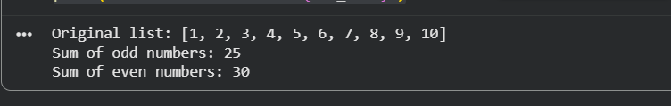

Cursor Ai:
#generate a program to calculate sum of odd and even numbers in a list
Code:
def sum_odd_even(numbers):
even_sum = 0
odd_sum = 0

for n in numbers:
if n % 2 == 0:
even_sum += n
else:
odd_sum += n

return even_sum, odd_sum

# Example usage
if __name__ == "__main__":
nums = [1, 2, 3, 4, 5, 6, 7]
even_total, odd_total = sum_odd_even(nums)
print("Sum of even numbers:", even_total)
print("Sum of odd numbers:", odd_total)
Output:
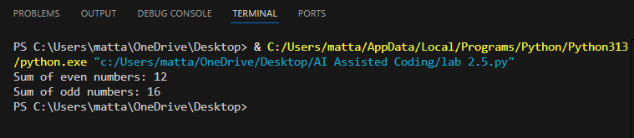
Task 2: Area Calculation Explanation
- Scenario:
You are onboarding a junior developer.
- Task:
Ask Gemini to explain a function that calculates the area of different shapes.
- Expected Output:
  - Code
  - Explanation

Gemini AI
Prompt:
#generate a code which explains a function that calculates the area of different shapes

Code:
import math

def calculate_area(shape, **kwargs):
"""
Calculates the area of different shapes.

Args:
shape (str): The type of shape ('circle', 'rectangle', 'triangle').
**kwargs: Keyword arguments for shape dimensions:
- For 'circle': 'radius'
- For 'rectangle': 'length', 'width'
- For 'triangle': 'base', 'height'

Returns:
float: The calculated area of the shape.
str: An error message if the shape or dimensions are invalid.
"""
if shape.lower() == 'circle':
radius = kwargs.get('radius')
if radius is not None and radius >= 0:
return math.pi * radius**2
else:
return "Error: For a circle, 'radius' must be a non-negative number."
elif shape.lower() == 'rectangle':
length = kwargs.get('length')
width = kwargs.get('width')
if length is not None and width is not None and length >= 0 and width >= 0:
return length * width
else:
return "Error: For a rectangle, 'length' and 'width' must be non-negative numbers."
elif shape.lower() == 'triangle':
base = kwargs.get('base')
height = kwargs.get('height')
if base is not None and height is not None and base >= 0 and height >= 0:
return 0.5 * base * height
else:
return "Error: For a triangle, 'base' and 'height' must be non-negative numbers."
else:
return "Error: Invalid shape. Supported shapes are 'circle', 'rectangle', and 'triangle'."

# --- Examples of using the function ---

# Calculate area of a circle
circle_area = calculate_area('circle', radius=5)
print(f"Area of circle with radius 5: {circle_area:.2f}")

# Calculate area of a rectangle
rectangle_area = calculate_area('rectangle', length=10, width=6)
print(f"Area of rectangle with length 10 and width 6: {rectangle_area}")

# Calculate area of a triangle
triangle_area = calculate_area('triangle', base=8, height=4)
print(f"Area of triangle with base 8 and height 4: {triangle_area}")

# Example with invalid input
invalid_shape_area = calculate_area('square', side=5)
print(f"Invalid shape example: {invalid_shape_area}")

invalid_dimensions_area = calculate_area('circle', radius=-2)
print(f"Invalid dimensions example: {invalid_dimensions_area}")

output:
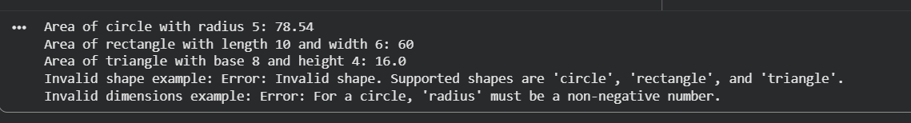
Explanation of the calculate_area function:
This Python function, calculate_area, is designed to compute the area of different geometric shapes based on their type and dimensions.
- import math: Imports the math module, which is used here for math.pi to calculate the area of a circle.
- Function Definition (def calculate_area(shape, **kwargs):):
  - It takes two main arguments:
    - shape (string): Specifies the type of shape (e.g., 'circle', 'rectangle', 'triangle').
    - **kwargs: This allows the function to accept an arbitrary number of keyword arguments. These arguments are used to pass the specific dimensions required for each shape (e.g., radius for a circle, length and width for a rectangle, base and height for a triangle).
- Conditional Logic (if-elif-else):
  - The function uses if-elif-else statements to determine which shape's area needs to be calculated.
  - Circle: If shape is 'circle', it retrieves the radius from kwargs. It then checks if the radius is provided and is non-negative before applying the formula π * radius².
  - Rectangle: If shape is 'rectangle', it retrieves length and width. It validates these inputs and calculates the area using length * width.
  - Triangle: If shape is 'triangle', it retrieves base and height. After validation, it calculates the area using 0.5 * base * height.
  - Error Handling: If an unsupported shape is provided, or if the required dimensions are missing or invalid for a given shape, the function returns an informative error message.
- Return Value: The function returns the calculated area as a float or an error message as a string.

Task 3: Prompt Sensitivity Experiment
- Scenario:
You are testing how AI responds to different prompts.

- Task:
Use Cursor AI with different prompts for the same problem and observe code changes.
- Expected Output:
  - Prompt list
  - Code variations

Prompt list:
# generate a code to find largest element in an array
# generate a optimized code to find largest element in an array
# generate a code to find largest element in an array using built in function
# generate a code to find largest element in an array without built in functions
# generate a code to find largest element in an array and also handle the empty lists
Code variations:
comparison of the approaches we covered:
- Language / snippet: Python for all.
- Goal: Find the largest element in an array (list).
- Complexity: All are O(n) time, O(1) extra space unless using built-ins (still O(1) extra space in practice).
Approach | Uses built-ins? | Handles empty list? | Code sketch | Pros | Cons
Single pass, manual | No | Yes (raises error) | largest = nums[0]; for v in nums[1:]: if v > largest: largest = v | Simple, explicit control, O(n)/O(1) | Slightly more code than built-in
Single pass, manual (without empty guard) | No | No (would error on empty) | same loop, but no empty check | Shortest manual loop | Must ensure non-empty input elsewhere
Built-in max(nums) | Yes (max) | Yes (with explicit check) | if not nums: raise ValueError(...); return max(nums) | Most concise, well-tested | Still O(n); requires import? (no)
Built-in max(nums) without guard | Yes | No (ValueError on empty) | return max(nums) | One-liner | Crashes on empty unless caller guards
Notes:
- All approaches are optimal for this task; the difference is mainly brevity vs. explicit control.
- For production, prefer either the guarded manual loop or max with an explicit empty check.

Task 4: Tool Comparison Reflection
- Scenario:
You must recommend an AI coding tool.

- Task:
Based on your work in this topic, compare Gemini, Copilot, and Cursor AI for usability and code quality.

- Expected Output:
Short written reflection
Note: Report should be submitted as a word document for all tasks in a single document with prompts, comments & code explanation, and output and if required, screenshots.
Code:
tools = [
{
"name": "Gemini",
"usability": "Strong chat UX; good clarifications; slower code-in-editor loop",
"code_quality": "Solid for explanations and small/medium tasks; may be cautious; fewer inline edits"
},
{
"name": "GitHub Copilot",
"usability": "Excellent inline suggestions; minimal chat; shines in flow; less guided Q&A",
"code_quality": "Great for idiomatic scaffolding; occasionally overconfident; needs review for edge cases"
},
{
"name": "Cursor AI",
"usability": "Tight editor integration; edit/apply patches; good multi-file awareness",
"code_quality": "Concise diffs; good at refactors; depends on prompts; verify complex logic"
},
]

for t in tools:
print(f"{t['name']}:")
print(f" Usability -> {t['usability']}")
print(f" Code quality -> {t['code_quality']}")
print()

output:
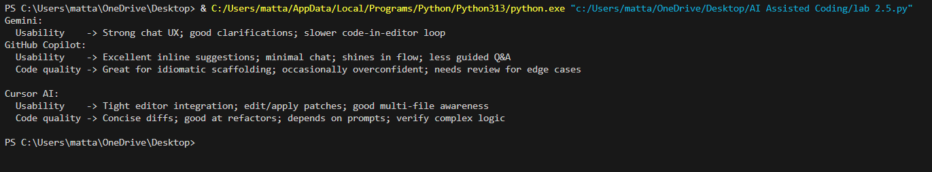
Short reflection
- Gemini: great for reasoning and step-by-step help; less frictionless for inline edits.
- Copilot: best for rapid inline completions during flow; needs human guardrails for correctness.
- Cursor AI: strong for applied edits and refactors with context; effectiveness scales with clear prompts and review.

